VITA HVAÐ ER GLOBALIZATION etc.

On each request.. there is **Accept-Language**.. which determines the language the client supports..

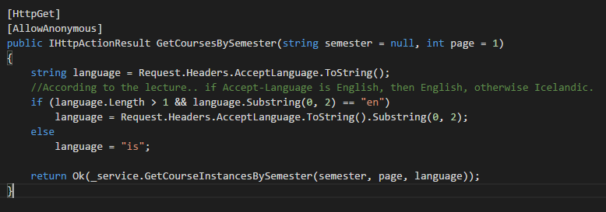

**Culture-sensitive data: CURRENCIES, DATES..**

**Internationalization => Globalization & Localization**

**Globalization =>** Designing apps to SUPPORT DIFFERENT CULTURES (**LANGUAGES AND REGIONS**).

**LOCALIZATION =>** Customizing an app for a given culture (language and region). Format for the culture name is „-„, where is the LANGUAGE CODE and the SUBCULTURE CODE. Like en-us.

Internationalization => Both

Culture: Language and optionally a region

Locale: A locale is the same as culture